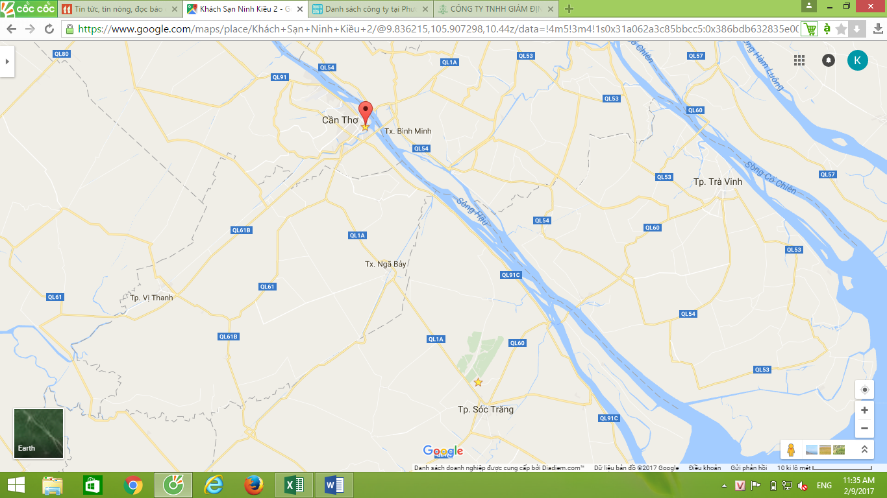
BIOWAY
HOTEL
- BIOWAY
BIOWAY

ADD: Plot Q1 N1 road An Nghiep Industrial Park - An Hiep Commune - Chau Thanh district - Soc Trang
TEL: 0918 309 926 (Ms.Tien) Or 0913 665 441 (Ms. Duyen)
EMAIL: camtien.bioway@gmail.com
- NINH KIEU 2 HOTEL
ADD: 03 Avenue Hoa Binh - Tan An Ward - Ninh Kieu District - Can Tho City
BIOWAY

TEL: +84 7103 789 777
Email: contact@ninhkieuhotel.com
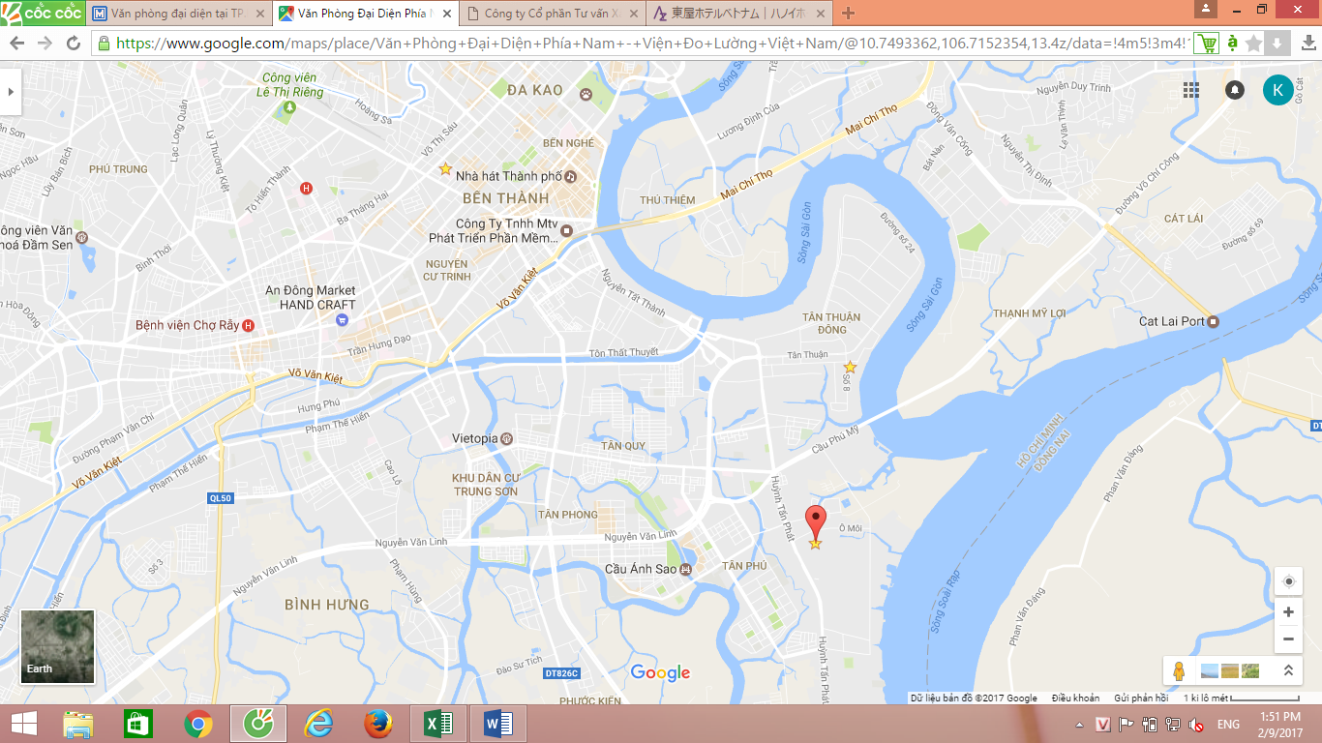
- PECC 2
VINACONTROL
PECC 2
VMI
ADD: 32 Ngo Thoi Nhiem, District 3, Ho Chi Minh City, Vietnam
TEL: 0906 090 105 (Mr.Toan)
EMAIL: toan.nv@pecc2.com
- VINACONTROL
ADD: U18A Block, Road 22, Tan Thuan Export Processing Zone, District 7, Ho Chi Minh City, Vietnam
TEL: 0913 911 738 (Mr.Dung)
EMAIL: labvinacontrol@yahoo.com
- VMI
ADD: 92C6 KDC Savimex - .Phú Thuận Ward - District 7 - HCM city
TEL: 0986 243 666 (Mr.Nam)
EMAIL: namtq.vmi@gmail.com
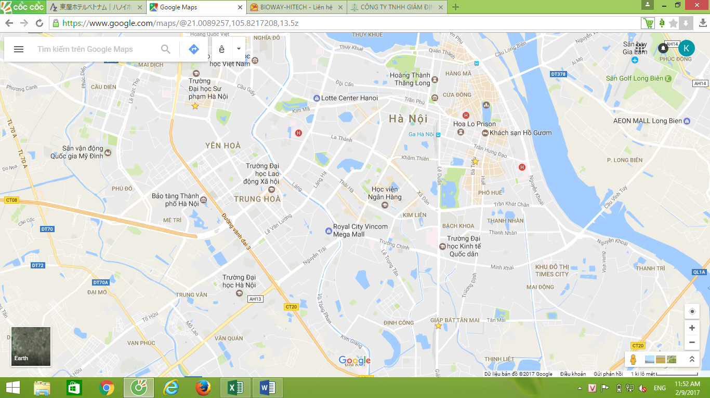

4.MHPS

1.HORIBA

3.AZUMAYA

2.CEM

4. MHPS
ADD: 10th Floor, Pacific Place Building, 83B Ly Thuong Kiet, Ha Noi
TEL (Mobile): +84-90-3209-281 (Mr. Takamitsu Saito)
TEL (Direct): +84-4-3933-3945
EMAIL: takamitsu_saito@mhps.com

- HORIBA VIETNAM Company Limited
ADD: Unit 06, 10 Floor, CMC Tower, Duy Tan Street, Dich Vong Hau Ward, Cau Giay District, Hanoi, Vietnam
TEL: 0969 653 008 (Mr.Dan)
EMAIL: nguyen.van-dan@horiba.com
- CEM
ADD: 813 Giai Phong Street;Giap Bat ward, Hoang Mai district, Ha Noi
TEL: 0912 770 337 (Ms.Anh)
EMAIL: nganh@cem.gov.vn
- AZUMAYA Hotel
Add: 16 Bui Thi Xuan St, Hai Ba Trưng Dist, Ha Noi
TEL: +84 4 6278 6688
EMAIL: reservationhanoi@azumayavietnam.com

